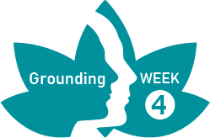
PRACTICE RECORD FORM
WEEK 4
Record on this form each time you practice. Make notes for discussion at the next session.

Day/date | Practice  (Yes/No) | Comments
Day/Date: | Seated meditation:  Breathe:  Mindful walking:
Day/Date: | Seated meditation:  Breathe:  Mindful walking:
Day/Date: | Seated meditation:  Breathe:  Mindful walking:
Day/Date: | Seated meditation:  Breathe:  Mindful walking:
Day/Date: | Seated meditation:  Breathe:  Mindful walking:
Day/Date: | Seated meditation:  Breathe:  Mindful walking:

