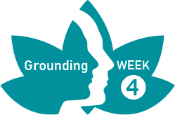
Seated Meditation – Instructions

This meditation can be conducted sitting down on a chair, cushion or mat.
- Practise mindfulness of breath and body as previously taught, to ground yourself in the present moment.
- Shift your attention away from the body and to your hearing. Start at your ears and then expand your focus to the awareness of sounds, close by or far way. Not labelling the sounds, just allowing them to emerge, pass by and finally pass away. Treat them as sensations rather than objects by focussing on the emergence, volume, timbre, pitch and duration.
- Let go of sound and focus on your thoughts, treat them the same as the sounds, letting them emerge, pass by and finally pass away, without the need for labelling. If it helps, imagine them as movie clips passing across the screen or as clouds floating past in the sky.
- Let go of thought now and focus back on the body, using the mountain technique to feel the energy flowing through your body in conjunction with your breath. Then pay attention to the contact points, then to clothing and then the space outside the body.
- Finally, filter back in from the outside, via the skin contact, through the contact points and breathing, to finally finish. Bringing the connectedness to self into your next activities.

